**NATIONAL UNIVERSITY OF SCIENCE & TECHNOLOGY**



SCHOOL OF MECHANICAL & MANUFACTURING ENGINEERING

**FUNDAMENTAL OF PROGRAMMINGS**

**LAB MANUAL 6**

**NAME**: HAMZA SAIF

**CMS** ID:481070

**SEC**: ME-15©

**LAB TASKS:**

**TASK#1:**

Generate the Fibonacci sequence using nested loops

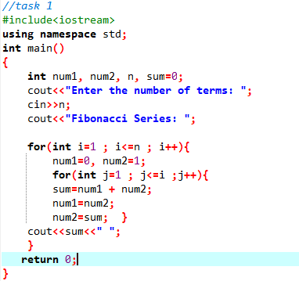

OUTPUT:

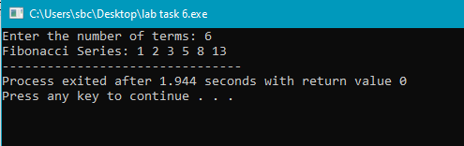

**TASK#2:**

Create Floyd’s Triangle with nested loops

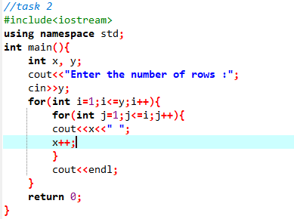

OUTPUT:

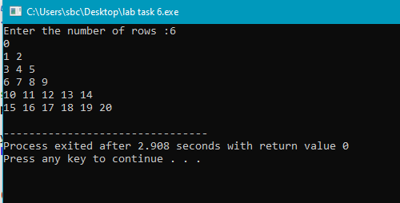

**HOME TASKS:**

**TASK#1:**

Write a program using break or continue statement that only adds prime numbers from 1 to 50 and display the sum on screen.

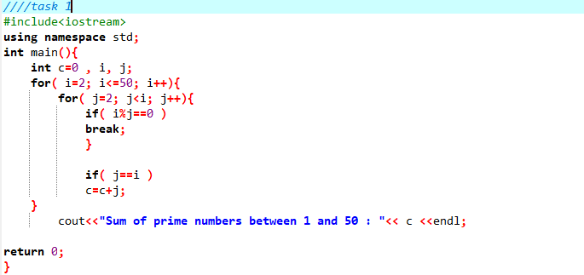

OUTPUT

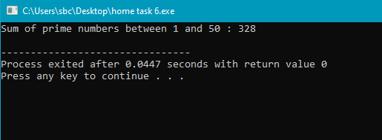

**TASK#2:**

Write a program in C++ to create the following pattern.

1

1 2

1 2 3

1 2 3 4

1 2 3 4 5

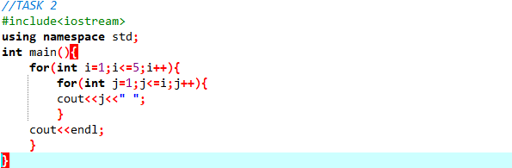

OUTPUT

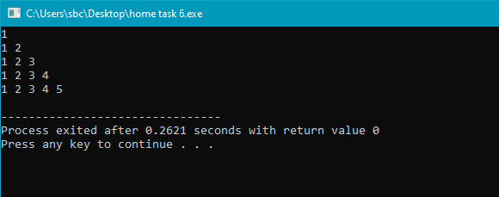

**TASK#3:**

Write a C++ program to print:

1

2 2

4 4 4 4

6 6 6 6 6 6

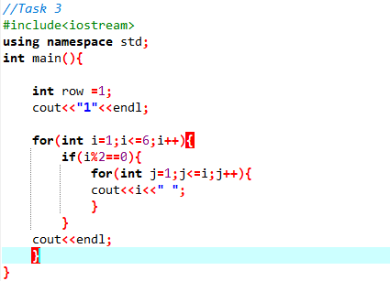

OUTPUT

